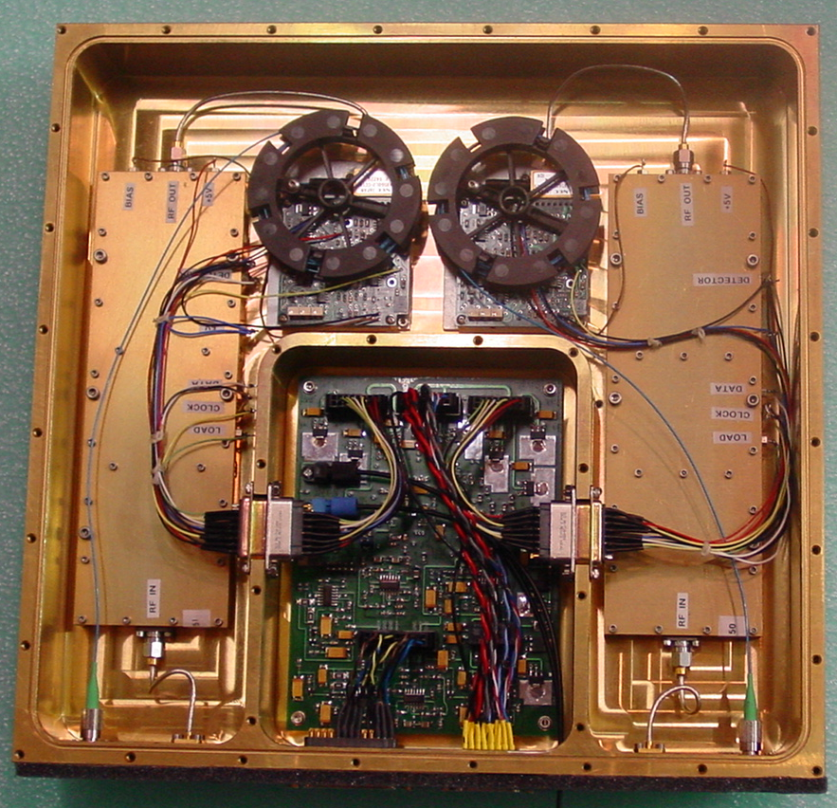
PAX with controller installed.

Place the copper block on IP2022 (on back side of controller) removing blue part of double-sided sticky tape and using a little dab of the white thermal grease.

